Chapter 20
The Distribution of Income
MULTIPLE CHOICE
1. The government’s policies enacted to make the distribution of income more equitable causes all of the following EXCEPT,
a. a less efficient allocation of resources.
b. a distortion of incentives.
c. altered behavior.
d. All of the above are correct.
ANSWER: d. All of the above are correct.
TYPE: M SECTION: 0 DIFFICULTY: 1
2. In the US, labor earnings are what percent of total income?
a. 75 percent
b. 70 percent
c. 65 percent
d. 50 percent
ANSWER: a. 75 percent
TYPE: M SECTION: 0 DIFFICULTY: 1
3. All of the following are problems with measuring inequality, EXCEPT that
a. the measurements usually do not include in-kind transfers.
b. the measurements use lifetime incomes rather than annual incomes.
c. the measurements should use permanent income, not including transitory changes.
d. poverty is long term for relatively few families.
ANSWER: b. the measurements use lifetime incomes rather than annual incomes.
TYPE: M SECTION: 1 DIFFICULTY: 1
4. The invisible hand of the marketplace acts to allocate resources
a. efficiently, but does not necessarily ensure that resources are allocated fairly.
b. fairly, and ensures that resources are allocated efficiently.
c. fairly, but does not necessarily ensure that resources are allocated efficiently.
d. efficiently, and ensures that resources are allocated equitably.
ANSWER: a. efficiently, but does not necessarily ensure that resources are allocated fairly.
TYPE: M SECTION: 0 DIFFICULTY: 1
5. The marketplace acts to allocate resources
a. fairly.
b. to those most desiring them.
c. efficiently.
d. efficiently and equitably.
ANSWER: c. efficiently.
TYPE: M SECTION: 0 DIFFICULTY: 1
6. The government enacts policies to make the
a. distribution of income more efficient.
b. distribution of income more fair.
c. redistribution of income more efficient.
d. redistribution of income more efficient and fair.
ANSWER: b. distribution of income more fair.
TYPE: M SECTION: 0 DIFFICULTY: 1
7. A person’s earnings depend on
a. whether or not the economy is experiencing inflation.
b. how well the economy is doing.
c. how much profit her employer is able to make.
d. the supply and demand for that person’s labor.
ANSWER: d. the supply and demand for that person’s labor.
TYPE: M SECTION: 0 DIFFICULTY: 1
8. Labor earnings make up what part of total income in the U.S. economy?
a. all of it
b. three-fourths
c. one-half
d. one-fourth
ANSWER: b. three-fourths
TYPE: M SECTION: 0 DIFFICULTY: 1
9. The income distribution in a society is largely
a. determined by the government’s policies.
b. determined by business decisions.
c. determined by factors that determine wages.
d. independent of market allocations of resources.
ANSWER: c. determined by factors that determine wages.
TYPE: M SECTION: 0 DIFFICULTY: 1
10. In general, the invisible hand of the marketplace acts to allocate resources
a. neither efficiently nor fairly.
b. fairly, but not necessarily efficiently.
c. efficiently and fairly.
d. efficiently, but not necessarily fairly.
ANSWER: d. efficiently, but not necessarily fairly.
TYPE: M SECTION: 0 DIFFICULTY: 1
11. When a government enacts policies that redistribute income, all of the following will occur EXCEPT:
a. the government will distort incentives.
b. a fair distribution of income will be ensured.
c. people will alter their market behavior.
d. markets will become less efficient at allocating resources to their highest valued use.
ANSWER: b. a fair distribution of income will be ensured.
TYPE: M SECTION: 0 DIFFICULTY: 1
12. A government’s policy of redistributing income makes the income distribution more equitable,
a. distorts incentives and makes the allocation of resources more efficient.
b. alters behavior and makes the allocation of resources more efficient.
c. distorts incentives and alters behavior.
d. distorts incentives and makes the allocation of resources less efficient.
ANSWER: d. distorts incentives and makes the allocation of resources less efficient.
TYPE: M SECTION: 0 DIFFICULTY: 1
13. All of the following are questions that need to be answered by a measurement of the distribution of income, EXCEPT:
a. How much inequality is there in our society?
b. How many people live in poverty?
c. How often do people receive raises?
d. What problems arise in measuring the amount of inequality?
ANSWER: c. How often do people receive raises?
TYPE: M SECTION: 1 DIFFICULTY: 1
14. Income inequality in an economy is traditionally measured by
a. calculating the bell curve of ability, effort and chance that exists in an economy.
b. calculating the percentage of families that fall into broad income classifications.
c. referring to standard international distribution tables.
d. using something like the normal distribution.
ANSWER: b. calculating the percentage of families that fall into broad income classifications.
TYPE: M SECTION: 1 DIFFICULTY: 1
15. Studying poverty and inequality of income helps to answer the question:
a. What are people’s wages?
b. How much experience is needed in different jobs?
c. How much inequality is there in society?
d. How do people adjust their behavior due to taxation?
ANSWER: c. How much inequality is there in society?
TYPE: M SECTION: 1 DIFFICULTY: 1
16. Comparison of the measures for household income distribution among countries reveals the
a. differences in income accounting procedures.
b. difficulty of making comparisons due to differences in how data are collected.
c. task is impossible, since each country measures income in a different currency.
d. task is relatively simple since international agreements require countries to standardize their income accounting procedures.
ANSWER: b. difficulty of making comparisons due to differences in how data are collected.
TYPE: M SECTION: 1 DIFFICULTY: 1
17. If income were equally distributed among households,
a. the household’s relative share of income would increase.
b. the household’s relative share of income would decline.
c. 50 percent of the households would receive exactly 50 percent of the income.
d. all households would become rich.
ANSWER: c. 50 percent of the households would receive exactly 50 percent of the income.
TYPE: M SECTION: 1 DIFFICULTY: 1
18. When measuring income distribution, the income share of the top fifth of all families is
a. over 50 percent.
b. about 10 times the income of the bottom fifth.
c. around 25 percent.
d. not much different from the income of the top 5 percent.
ANSWER: b. about 10 times the income of the bottom fifth.
TYPE: M SECTION: 1 DIFFICULTY: 1
19. The recent rise in inequality from 1970 to 2000 can be at least partially explained by
a. increased international trade with low-cost countries.
b. changes in technology.
c. a reduction in the demand for unskilled labor.
d. an increase in minimum wages.
ANSWER: a. increased international trade with low-cost countries.
TYPE: M SECTION: 1 DIFFICULTY: 1
20. The women’s movement has had its greatest impact on women from
a. low-income households.
b. low- to middle-income households.
c. middle-income households.
d. high-income households.
ANSWER: d. high-income households.
TYPE: M SECTION: 1 DIFFICULTY: 1
21. Based on data from 2000, approximately what percent of all income in the United States did the top fifth of all families receive?
a. 78 percent
b. 47 percent
c. 32 percent
d. 4 percent
ANSWER: b. 47 percent
TYPE: M SECTION: 1 DIFFICULTY: 1
22. Based on U.S. income data from 2000, approximately what percent of all income did the bottom fifth of all families receive?
a. 48 percent
b. 12 percent
c. 8 percent
d. 4 percent
ANSWER: d. 4 percent
TYPE: M SECTION: 1 DIFFICULTY: 1
23. Based on U.S. income data from 2000, the top fifth of all families received approximately how many times as much income as the bottom fifth?
a. 10
b. 5
c. 3
d. 2
ANSWER: a. 10
TYPE: M SECTION: 1 DIFFICULTY: 1
24. U.S. income data over the last sixty years suggests that the distribution of income
a. has gradually become more equal over the entire time period.
b. has gradually become less equal over the entire time period.
c. gradually became less equal until about 1970, and then reversed itself.
d. gradually became more equal until about 1970, and then reversed itself.
ANSWER: d. gradually became more equal until about 1970, and then reversed itself.
TYPE: M SECTION: 1 DIFFICULTY: 1
25. Evidence suggests that the women's movement has
a. decreased income inequality across households.
b. increased income inequality across households.
c. had no effect on the distribution of income across households.
d. decreased the importance of traditional measures of income inequality.
ANSWER: b. increased income inequality across households.
TYPE: M SECTION: 1 DIFFICULTY: 1
26. Part of the increase in inequality measures is due to
a. the urbanization of society.
b. the women's movement.
c. technological change.
d. the migration of low-income jobs out of urban centers.
ANSWER: b. the women's movement.
TYPE: M SECTION: 1 DIFFICULTY: 1
27. A measurement instrument of the distribution of income in our society must
a. explain inequality.
b. explain why people live below poverty.
c. tell how many people live in poverty.
d. All of the above are correct.
ANSWER: c. tell how many people live in poverty.
TYPE: M SECTION: 1 DIFFICULTY: 1
28. The U.S. distribution of income
a. became more fair up to 1970 and less fair after.
b. became less equitable since 1935.
c. has been remarkably stable over time.
d. has averaged over 50 percent in the top fifth income bracket since 1935.
ANSWER: a. became more fair up to 1970 and less fair after.
TYPE: M SECTION: 1 DIFFICULTY: 1
29. A table of quintiles (fifths) of the 2000 U.S. income distribution reports
a. 50 percent of income in the lower 3 fifths.
b. 40 percent of income in the upper 2 fifths.
c. over 20 percent of income in the top fifth.
d. over 70 percent of income in the top 2 fifths.
ANSWER: d. over 70 percent of income in the top 2 fifths.
TYPE: M SECTION: 1 DIFFICULTY: 1
30. A cross-country comparison of income distributions suggests that the United States
a. has one of the most unequal income distributions.
b. has a higher percentage of poor families, and a higher percentage of rich families than most countries.
c. has a distribution is somewhere in the middle of the pack.
d. has one of the most equal income distributions.
ANSWER: c. has a distribution is somewhere in the middle of the pack.
TYPE: M SECTION: 1 DIFFICULTY: 1
31. The country that has the highest inequality of income is
a. the United States.
b. Germany.
c. Russia.
d. Brazil.
ANSWER: d. Brazil.
TYPE: M SECTION: 1 DIFFICULTY: 1
32. Cross-country distribution of income comparisons show that among the developed countries the United States has relatively greater
a. equality but less equality than the developing countries.
b. equality but is more equal than the developing countries.
c. inequality but less equality than the developing countries.
d. inequality but is more equal than the developing countries.
ANSWER: d. inequality but is more equal than the developing countries.
TYPE: M SECTION: 1 DIFFICULTY: 1
33. The poverty rate includes income,
a. in-kind transfers, and other government assistance aid.
b. in-kind transfers, and housing assistance only.
c. and in-kind transfers only.
d. and nothing else.
ANSWER: d. and nothing else.
TYPE: M SECTION: 1 DIFFICULTY: 1
34. In the United States, the poverty rate is a measure of the percentage of people whose income falls below
a. an identified income standard.
b. the median family of four income.
c. the amount of expenditures for a family.
d. an average level of income.
ANSWER: a. an identified income standard.
TYPE: M SECTION: 1 DIFFICULTY: 1
35. In 2000, the poverty rate in the United States was approximately
a. 10.9 percent.
b. 11.3 percent.
c. 12.7 percent.
d. 14.1 percent.
ANSWER: b. 11.3 percent.
TYPE: M SECTION: 1 DIFFICULTY: 1
36. In 2000, the poverty line for a family of four was (approximately)
a. $14,500.
b. $16,660.
c. $17,600.
d. $20,330.
ANSWER: c. $17,600.
TYPE: M SECTION: 1 DIFFICULTY: 1
37. The poverty line reflects an annual income equal to approximately
a. five times the cost of providing an adequate diet.
b. four times the cost of providing an adequate diet.
c. three times the cost of providing an adequate diet.
d. two times the cost of providing an adequate diet.
ANSWER: c. three times the cost of providing an adequate diet.
TYPE: M SECTION: 1 DIFFICULTY: 1
38. The poverty line is adjusted each year to reflect changes in the
a. number of people currently on public assistance.
b. level of prices.
c. nutritional content of an "adequate" diet.
d. size of a family.
ANSWER: b. level of prices.
TYPE: M SECTION: 1 DIFFICULTY: 1
39. Over the past 50 years, the U.S. poverty rate was at its lowest level in
a. 1960.
b. 1970.
c. 1980.
d. 1990.
ANSWER: b. 1970.
TYPE: M SECTION: 1 DIFFICULTY: 1
40. Over the past few years, growth in average income has
a. appreciably decreased the poverty rate.
b. increased poverty.
c. failed to appreciably decrease the poverty rate.
d. increased the poverty rate in some years, and decreased it in other years.
ANSWER: c. failed to appreciably decrease the poverty rate.
TYPE: M SECTION: 1 DIFFICULTY: 1
41. Based on U.S. data for 2000, relative to the population as a whole, the poverty rate has been highest for
a. children.
b. Asians.
c. blacks and Hispanics.
d. the elderly.
ANSWER: c. blacks and Hispanics.
TYPE: M SECTION: 1 DIFFICULTY: 1
42. Poverty is found to be correlated with
a. race.
b. age.
c. family composition.
d. All of the above are correct.
ANSWER: d. All of the above are correct.
TYPE: M SECTION: 1 DIFFICULTY: 1
43. Measuring poverty using an absolute income scale (like the poverty line) is likely to be deceptive because
a. income measures don't include the value of in-kind transfers.
b. money is more highly valued by the poor than by the rich.
c. the poor are not likely to participate in the labor market.
d. income is not correlated with job satisfaction.
ANSWER: a. income measures don't include the value of in-kind transfers.
TYPE: M SECTION: 1 DIFFICULTY: 1
44. If the value of in-kind transfers are taken into account, the number of families living in poverty in the United States would
a. increase by about 1 percent.
b. decline by about 1 percent.
c. decline by about 5 percent.
d. decline by about 10 percent.
ANSWER: d. decline by about 10 percent.
TYPE: M SECTION: 1 DIFFICULTY: 1
45. All of the following are examples of in-kind transfers, EXCEPT
a. food stamps.
b. Medicare.
c. the Earned Income Tax Credit.
d. housing vouchers.
ANSWER: c. the Earned Income Tax Credit.
TYPE: M SECTION: 1 DIFFICULTY: 1
46. Measures of poverty that fail to account for the value of in-kind transfers
a. understate the actual poverty rate.
b. have little effect on the validity of reported poverty rates.
c. are generally more reliable in accounting for annual variation in actual poverty rates.
d. overstate the actual poverty rate.
ANSWER: d. overstate the actual poverty rate.
TYPE: M SECTION: 1 DIFFICULTY: 1
47. In-kind transfers are
a. obtained only by those who are crafty and politically connected.
b. only provided by the U. S. government.
c. non-monetary items given to the poor.
d. obtained primarily through soup kitchens.
ANSWER: c. non-monetary items given to the poor.
TYPE: M SECTION: 1 DIFFICULTY: 1
48. The women’s movement has changed the behavior of
a. very few wives.
b. the wives of low- to middle-income men.
c. the wives of middle-income men.
d. the wives of high-income men.
ANSWER: d. the wives of high income men.
TYPE: M SECTION: 1 DIFFICULTY: 1
49. A commonly used gauge of the distribution of income is
a. IIR (income inequality rate)
b. the average income rate.
c. the poverty rate.
d. the social inequality rate.
ANSWER: c. the poverty rate.
TYPE: M SECTION: 1 DIFFICULTY: 1
50. Poverty affects all groups but the frequency of poverty is correlated with
a. race, age, and height.
b. age, race, and weight.
c. age, weight, height, and family composition.
d. age, race, and family composition.
ANSWER: d. age, race, and family composition.
TYPE: M SECTION: 1 DIFFICULTY: 1
51. Government programs that take money from high-income people to give it to low-income people typically
a. improve economic efficiency by reducing poverty.
b. reduce economic efficiency because they distort incentives.
c. have no effect on economic efficiency because they both reduce poverty and distort incentives.
d. sometimes improve, sometimes reduce, and sometimes have no effect on economic efficiency.
ANSWER: b. reduce economic efficiency because they distort incentives.
TYPE: M SECTION: 0 DIFFICULTY: 1
52. The women’s movement in the United States has
a. helped make the distribution of family income in the United States more unequal.
b. helped make the distribution of family income in the United States more equal.
c. not affected the distribution of family income in the United States
d. reduced the percent of households headed by women.
ANSWER: a. helped make the distribution of family income in the United States more unequal.
TYPE: M SECTION: 1 DIFFICULTY: 1
53. The women’s movement in the United States has increased the rate of labor-force participation of
a. low-income women more than that of high-income women.
b. low-income women less than that of high-income women.
c. middle-income women more than that of low-income or high-income women.
d. women in all income classes by about the same amount.
ANSWER: b. low-income women less than that of high-income women.
TYPE: M SECTION: 1 DIFFICULTY: 1
54. Which of the following statements is true?
a. The distribution of annual income accurately reflects the distribution of living standards.
b. Lifetime incomes are more equally distributed than annual incomes.
c. Transitory changes in income generally have a significant impact on a family’s standard of living.
d. Annual income is more equally distributed than permanent income.
ANSWER: b. Lifetime incomes are more equally distributed than annual incomes.
TYPE: M SECTION: 1 DIFFICULTY: 2
55. The poverty line in the country of Equalia is $10,000. The distribution of income for Equalia is as follows:

Number of Families | Income
200 | less than $5,000
300 | between $5,000 and $10,000
500 | between $10,000 and $15,000
700 | between $15,000 and $20,000
100 | over $20,000

The poverty rate in Equalia is
a. 11.1 percent.
b. 16.7 percent.
c. 27.8 percent.
d. 55.5 percent.
ANSWER: c. 27.8 percent.
TYPE: M SECTION: 1 DIFFICULTY: 2
56. Which of the following statements are true?
a. Less than 3 percent of families are categorized as poor for eight years or more.
b. In the United States, the grandson of a millionaire is more likely to be rich than the grandson of an average-income person.
c. The majority of millionaires in the United States inherited their wealth.
d. Most workers have about the same income (adjusted for inflation) when they are young as when they are middle-aged.
ANSWER: a. Less than 3 percent of families are categorized as poor for eight years or more.
TYPE: M SECTION: 1 DIFFICULTY: 2
57. All of the following are reasons that data on income distribution and the poverty rate give an incomplete picture of inequality, EXCEPT
a. in-kind transfers.
b. economic life cycle.
c. transitory income.
d. economic immobility.
ANSWER: d. economic immobility.
TYPE: M SECTION: 1 DIFFICULTY: 2
58. Economists refer to the regular pattern of income variation over a person's lifetime as the
a. life cycle effect.
b. life pattern effect.
c. cyclical redundancy effect.
d. periodic cycle effect.
ANSWER: a. life cycle effect.
TYPE: M SECTION: 1 DIFFICULTY: 1
59. The Economic Life Cycle includes all of the following EXCEPT, incomes
a. are low for young workers.
b. fall sharply at retirement.
c. rise as the worker gains experience.
d. peak at around age 50.
ANSWER: b. fall sharply at retirement.
TYPE: M SECTION: 1 DIFFICULTY: 1
60. A hail storm would affect a farmer’s
a. permanent income.
b. economic life cycle income.
c. transitory income.
d. natural income.
ANSWER: c. transitory income.
TYPE: M SECTION: 1 DIFFICULTY: 2
61. In the United States, a worker’s highest income is around age
a. 65.
b. 50.
c. 40.
d. 30.
ANSWER: b. 50.
TYPE: M SECTION: 1 DIFFICULTY: 1
62. People have their highest saving rates when they are
a. retired.
b. middle-aged.
c. married with young children.
d. young and single.
ANSWER: b. middle-aged.
TYPE: M SECTION: 1 DIFFICULTY: 1
63. The life cycle effect characterizes a lifetime income profile in which income
a. tends to follow a seasonal pattern.
b. rises as a worker gains maturity and experience.
c. rises and falls in conjunction with the business cycle.
d. falls during the early years of market activity and peaks at retirement.
ANSWER: b. rises as a worker gains maturity and experience.
TYPE: M SECTION: 1 DIFFICULTY: 3
64. Because people can borrow when they are young, the life cycle theory would suggest that one’s standard of living depends on
a. lifetime income rather than annual income.
b. aggregate income rather than annual personal income.
c. annual extended family income rather than annual personal income.
d. income averaged across seasons rather than across years.
ANSWER: a. lifetime income rather than annual income.
TYPE: M SECTION: 1 DIFFICULTY: 3
65. Permanent income theory suggests that a person's income is composed of predictable life cycle variation and
a. structural change in the economy.
b. random and transitory forces in the economy.
c. aggregate variation resulting from predictable business cycles.
d. permanent changes that reflect the seasonal capacity of the economy.
ANSWER: b. random and transitory forces in the economy.
TYPE: M SECTION: 1 DIFFICULTY: 3
66. An example of a transitory change in income is the
a. annual cost of living adjustment to your salary.
b. increase in income that results from a job promotion linked to your education.
c. increase in income of California orange growers that results from an orange-killing frost in Florida.
d. All of the above are correct.
ANSWER: c. the increase in income of California orange growers that results from an orange-killing frost in Florida.
TYPE: M SECTION: 1 DIFFICULTY: 1
67. Saving and borrowing behavior is indicative of a family
a. that is most likely to be poor.
b. that has a difficult time balancing its standard of living.
c. adjusting its standard of living to reflect transitory changes in income.
d. that is most likely to be on the upper end of the income distribution.
ANSWER: c. adjusting its standard of living to reflect transitory changes in income.
TYPE: M SECTION: 1 DIFFICULTY: 1
68. The current formula for computing the poverty line was created during the administration of
a. Jimmy Carter.
b. Ronald Reagan.
c. John Kennedy.
d. Lyndon Johnson.
ANSWER: d. Lyndon Johnson.
TYPE: M SECTION: 1 DIFFICULTY: 1
69. The poverty line calculation makes no allowance for any of the following EXCEPT
a. transportation.
b. child care.
c. the level of prices.
d. Earned Income Tax Credit.
ANSWER: c. the level of prices.
TYPE: M SECTION: 1 DIFFICULTY: 1
70. The poverty line is adjusted for all of the following EXCEPT
a. food stamps.
b. regional cost-of-living differences.
c. Earned Income Tax Credit.
d. All of the above are correct.
ANSWER: d. All of the above are correct.
TYPE: M SECTION: 1 DIFFICULTY: 1
71. A family’s ability to buy goods and services depends largely on its
a. in-kind transfers.
b. annual income.
c. transitory income.
d. permanent income.
ANSWER: d. permanent income.
TYPE: M SECTION: 1 DIFFICULTY: 1
72. Economists who study economic mobility have found that, if a father earns 20 percent above his generation's average income, his son will most likely earn
a. an income equal to his generation's average income.
b. 8 percent above his generation's average income.
c. 5 percent below his generation's average income.
d. 3 percent above his generation's average income.
ANSWER: b. 8 percent above his generation's average income.
TYPE: M SECTION: 1 DIFFICULTY: 1
73. Economists who study economic mobility have found that the income of a grandfather and his grandson's income are
a. not related.
b. negatively related.
c. directly related.
d. exactly equal.
ANSWER: a. not related.
TYPE: M SECTION: 1 DIFFICULTY: 1
74. What percent of families are poor for eight or more years?
a. between 15 and 18 percent
b. between 10 and 12 percent
c. approximately 5 percent
d. less than 3 percent
ANSWER: d. less than 3 percent
TYPE: M SECTION: 1 DIFFICULTY: 1
75. Movement of individuals among income classes is likely to be caused by
a. chance (or luck).
b. laziness.
c. hard work.
d. All of the above are correct.
ANSWER: d. All of the above are correct.
TYPE: M SECTION: 1 DIFFICULTY: 1
76. Economic mobility refers to the
a. government’s attempt to distribute monetary assistance to areas most in need.
b. ability of families to freely relocate to find good jobs.
c. movement of people among income classes.
d. movement of resources from one industry to another.
ANSWER: c. movement of people among income classes.
TYPE: M SECTION: 1 DIFFICULTY: 2
77. Economic mobility complicates measurement of income inequality because
a. fewer than 3 percent of families are poor for 8 or more years.
b. over 5 million households in the United States had net worth (assets minus liabilities) that exceeded $1 million.
c. four of five of millionaires inherit their wealth.
d. All of the above are correct.
ANSWER: a. fewer than 3 percent of families are poor for 8 or more years.
TYPE: M SECTION: 2 DIFFICULTY: 2
78. Income mobility studies suggest that poverty
a. cannot be alleviated by privately sponsored anti-poverty programs.
b. cannot be alleviated by government sponsored anti-poverty programs.
c. is a long-term problem for a relatively large number of families.
d. is not a long-term problem for most families.
ANSWER: d. is not a long-term problem for most families.
TYPE: M SECTION: 1 DIFFICULTY: 1
79. According to 1996 U.S. income data, about how many households had a net worth that exceeded $1 million?
a. 947 thousand
b. 1.8 million
c. 2.7 million
d. 3.5 million
ANSWER: c. 2.7 million
TYPE: M SECTION: 1 DIFFICULTY: 1
80. Data for the United States suggests that about how many millionaires inherited their fortunes?
a. one in seven
b. one in five
c. one in three
d. one in two
ANSWER: b. one in five
TYPE: M SECTION: 1 DIFFICULTY: 1
81. Economic mobility contributes to
a. society’s ills through making the rich richer.
b. society’s ills through making the poor poorer.
c. Both of the above are correct.
d. None of the above are correct.
ANSWER: d. None of the above are correct.
TYPE: M SECTION: 1 DIFFICULTY: 2
82. Economic mobility in the United States means that fewer than
a. 3 percent of families are poor for eight or more years.
b. 5 percent of families are poor for eight or more years.
c. 8 percent of families are poor for eight or more years.
d. 10 percent of families are poor for eight or more years.
ANSWER: a. 3 percent of families are poor for eight or more years.
TYPE: M SECTION: 1 DIFFICULTY: 1
83. Estimates of about 2.7 millionaires in 1996 is an example of economic mobility because
a. they are millionaires.
b. their net worth places them in the richest 2.8 percent.
c. about four of five did not inherit their wealth.
d. All of the above are correct.
ANSWER: c. about four of five did not inherit their wealth.
TYPE: M SECTION: 1 DIFFICULTY: 1
84. “From shirtsleeves to shirtsleeves in three generations,” is an old saying relating to which problem in measuring inequality?
a. in-kind transfers
b. economic life cycle
c. transitory versus permanent income
d. economic mobility
ANSWER: d. economic mobility
TYPE: M SECTION: 1 DIFFICULTY: 1
85. To the extent that a family saves and borrows to buffer itself relates to which problem in measuring inequality?
a. in-kind transfers
b. economic life cycle
c. transitory versus permanent income
d. economic mobility
ANSWER: c. transitory versus permanent income
TYPE: M SECTION: 1 DIFFICULTY: 1
86. The fact that the young often borrow and then repay these loans when older relates to which problem in measuring inequality?
a. in-kind transfers
b. economic life cycle
c. transitory versus permanent income
d. economic mobility
ANSWER: b. economic life cycle
TYPE: M SECTION: 1 DIFFICULTY: 1
87. The statement, “measures of the distribution of income are based on money income” relates to which problem in measuring inequality?
a. in-kind transfers
b. economic life cycle
c. transitory versus permanent income
d. economic mobility
ANSWER: a. in-kind transfers
TYPE: M SECTION: 1 DIFFICULTY: 1
88. Whether or not policymakers should try to make our society more egalitarian is largely a matter of
a. economic efficiency.
b. political philosophy.
c. egalitarian principles.
d. enhanced opportunity.
ANSWER: b. political philosophy.
TYPE: M SECTION: 2 DIFFICULTY: 2
89. The founders of utilitarianism include
a. A. C. Pigou and John Maynard Keynes.
b. Jeremy Bentham and John Stuart Mill.
c. Augustin Cournot and Jean B. Say.
d. A. Kondratieff and Thomas Malthus.
ANSWER: b. Jeremy Bentham and John Stuart Mill.
TYPE: M SECTION: 2 DIFFICULTY: 1
90. According to utilitarians, the ultimate objective of private and public actions is to
a. enhance the income of the rich.
b. ensure an egalitarian distribution of income.
c. maximize the sum of individual utility.
d. provide for the betterment of the poor.
ANSWER: c. maximize the sum of individual utility.
TYPE: M SECTION: 2 DIFFICULTY: 2
91. The concept of utility is fundamental to utilitarianism and describes the
a. optimal distribution of wealth in society.
b. level of satisfaction derived from a person's circumstances.
c. method by which society chooses to allocate resources.
d. method whereby wealth is stored.
ANSWER: b. level of satisfaction derived from a person's circumstances.
TYPE: M SECTION: 2 DIFFICULTY: 2
92. The utilitarian case for redistributing income is based on the assumption of
a. collective consensus.
b. a notion of fairness engendered by equality.
c. diminishing marginal utility.
d. rising marginal utility.
ANSWER: c. diminishing marginal utility.
TYPE: M SECTION: 2 DIFFICULTY: 1
93. The concept of diminishing marginal utility is embodied in the utilitarian rationale for
a. trickle-down effects.
b. enhancing market efficiency.
c. redistributing income.
d. maintaining the status quo income distribution.
ANSWER: c. redistributing income.
TYPE: M SECTION: 2 DIFFICULTY: 1
94. Diminishing marginal utility suggests that
a. more is always preferred to less.
b. the well-being of society is maximized when the distribution of income is equal.
c. the poor are less efficient at spending money than the rich.
d. the poor receive more satisfaction than the rich from the last dollar they respectively spend.
ANSWER: d. the poor receive more satisfaction than the rich from the last dollar they respectively spend.
TYPE: M SECTION: 2 DIFFICULTY: 1
95. Ms. Spring currently earns $100,000 a year, while her junior partner, Mr. Fall, earns $55,000 a year. From the perspective of a utilitarian, if both of their incomes are subject to diminishing marginal utility, taking a dollar from Ms. Spring and giving it to Mr. Fall will
a. increase society's total utility.
b. lower Ms. Spring's marginal utility of income.
c. increase Mr. Fall's marginal utility of income.
d. None of the above are correct.
ANSWER: a. increase society's total utility.
TYPE: M SECTION: 2 DIFFICULTY: 1
96. “An extra dollar of income is worth more additional satisfaction to a poor person than to a rich person.” This is an important assumption of which political philosophy?
a. Utilitarianism
b. Liberalism
c. Libertarianism
d. None of the above are correct.
ANSWER: a. Utilitarianism
TYPE: M SECTION: 2 DIFFICULTY: 1
97. Which political philosophy believes in balancing the gains from greater equality against the losses from distorted incentives?
a. Utilitarianism
b. Liberalism
c. Libertarianism
d. None of the above are correct.
ANSWER: a. Utilitarianism
TYPE: M SECTION: 2 DIFFICULTY: 3
98. Which political philosophy believes that the government should make society fully equal?
a. Utilitarianism
b. Liberalism
c. Libertarianism
d. None of the above are correct.
ANSWER: d. None of the above are correct.
TYPE: M SECTION: 2 DIFFICULTY: 2
99. Raising total utility is which political philosophy’s prime objective?
a. Utilitarianism
b. Liberalism
c. Libertarianism
d. None of the above are correct.
ANSWER: a. Utilitarianism
TYPE: M SECTION: 2 DIFFICULTY: 1
100. When the government taxes income as part of a redistribution program
a. the poor pay higher taxes.
b. the rich always benefit more than the poor.
c. incentives for the poor to work are enhanced.
d. incentives to earn income are diminished.
ANSWER: d. incentives to earn income are diminished.
TYPE: M SECTION: 2 DIFFICULTY: 1
101. When incentives to earn income are distorted by income redistribution programs
a. losses can exceed potential gains from greater equality of income.
b. total income in an economy can fall.
c. total aggregate utility in society can fall.
d. All of the above are correct.
ANSWER: d. All of the above are correct.
TYPE: M SECTION: 2 DIFFICULTY: 1
102. All of the following will occur when government policies are enacted to make the distribution of income more equitable, EXCEPT
a. behavior is altered.
b. incentives are distorted.
c. total utility is constant.
d. the allocation of resources is less efficient.
ANSWER: c. total utility is constant.
TYPE: M SECTION: 2 DIFFICULTY: 2
103. As a result of the trade-off between income equality and incentives to work, an optimal redistribution policy
a. can never be funded through taxes on wage income.
b. must always achieve a full egalitarian society.
c. is only consistent with transfers to the middle class.
d. always falls short of a full egalitarian society.
ANSWER: d. always falls short of a full egalitarian society.
TYPE: M SECTION: 2 DIFFICULTY: 2
104. In the parable of the leaky bucket, a fundamental problem with government redistribution programs is identified. As long as the government only has "leaky buckets" at its disposal
a. affirmative action programs are doomed to failure.
b. it should not try to reach complete equality in income.
c. full egalitarian policies will always dominate competing policy options.
d. equality of economic opportunity is an unattainable goal.
ANSWER: b. it should not try to reach complete equality in income.
TYPE: M SECTION: 2 DIFFICULTY: 3
105. We are sitting in an “original position” behind a “veil of ignorance.” This is a statement attributed to which political philosophy?
a. Utilitarianism
b. Liberalism
c. Libertarianism
d. None of the above are correct.
ANSWER: b. Liberalism
TYPE: M SECTION: 2 DIFFICULTY: 2
106. Liberalism is a label that was coined for the view espoused by
a. Robert Nozick.
b. John Stuart Mill.
c. John Rawls.
d. Jeremy Bentham.
ANSWER: c. John Rawls.
TYPE: M SECTION: 2 DIFFICULTY: 1
107. Liberalism is founded on a premise that behind a "veil of ignorance"
a. justice can never be agreed upon.
b. no one would be considered in an "original position".
c. everyone would agree to "just" rules to reallocate income.
d. justice is a matter of political philosophy.
ANSWER: c. everyone would agree to "just" rules to reallocate income.
TYPE: M SECTION: 2 DIFFICULTY: 1
108. According to the doctrine of liberalism, principles of justice are the result of
a. fair agreement and bargain.
b. command-and-control policies.
c. domination of the powerful by the weak.
d. workers owning the factors of production.
ANSWER: a. fair agreement and bargain.
TYPE: M SECTION: 2 DIFFICULTY: 1
109. The minimax criterion is attributed to which political philosophy?
a. Utilitarianism
b. Liberalism
c. Libertarianism
d. None of the above are correct.
ANSWER: d. None of the above are correct.
TYPE: M SECTION: 2 DIFFICULTY: 2
110. The maximin criterion is attributed to which political philosophy?
a. Utilitarianism
b. Liberalism
c. Libertarianism
d. None of the above are correct.
ANSWER: b. Liberalism
TYPE: M SECTION: 2 DIFFICULTY: 1
111. Raising the welfare of the worst-off person in society is an important aim to which political philosophy?
a. Utilitarianism
b. Liberalism
c. Libertarianism
d. None of the above are correct.
ANSWER: b. Liberalism
TYPE: M SECTION: 2 DIFFICULTY: 1
112. The political philosophy that allows us to consider the redistribution of income as a form of social insurance is
a. Utilitarianism
b. Liberalism
c. Libertarianism
d. None of the above are correct.
ANSWER: b. Liberalism
TYPE: M SECTION: 2 DIFFICULTY: 2
113. The liberalism rule called the maximin criterion suggests that the focus of social policy would be to
a. expropriate the factors of production from the capitalist class.
b. ensure an egalitarian distribution of income.
c. elevate the well-being of those at the bottom of the income distribution.
d. elevate the well-being of all workers.
ANSWER: c. elevate the well-being of those at the bottom of the income distribution.
TYPE: M SECTION: 2 DIFFICULTY: 1
114. The rule for redistribution proposed by John Rawls in his book A Theory of Justice is called the
a. "veil of ignorance" criterion.
b. optimizing agent rule.
c. maximin criterion.
d. egalitarian principle.
ANSWER: c. maximin criterion.
TYPE: M SECTION: 2 DIFFICULTY: 1
115. According to the maximin criterion, income would be transferred from the rich to the poor as long as it
a. raises the well-being of the least fortunate.
b. does not alter incentives to work and save.
c. promotes an egalitarian distribution of income.
d. enhances the welfare of workers.
ANSWER: a. raises the well-being of the least fortunate.
TYPE: M SECTION: 2 DIFFICULTY: 1
116. The founders of utilitarianism include
a. John Stuart Mill & Jeremy Bentham
b. John Rawls
c. Robert Nozick
d. Milton Friedman
ANSWER: a. John Stuart Mill & Jeremy Bentham
TYPE: M SECTION: 2 DIFFICULTY: 1
117. The maximin criterion of maximizing the well-being of the worst off person in society is representative of the __________ political philosophy.
a. utilitarian
b. liberal
c. libertarian
d. None of the above are correct.
ANSWER: b. liberal
TYPE: M SECTION: 2 DIFFICULTY: 1
118. The political philosophy which believes in focusing on evaluating the process of determining the distribution of income rather than on the outcomes, is
a. utilitarianism
b. liberalism
c. libertarianism
d. None of the above are correct.
ANSWER: c. libertarianism
TYPE: M SECTION: 2 DIFFICULTY: 1
119. The political philosophy that believes that the government should continue to redistribute income until everyone in society has exactly the same income is
a. utilitarian
b. liberal
c. libertarian
d. None of the above are correct.
ANSWER: d. None of the above are correct.
TYPE: M SECTION: 2 DIFFICULTY: 1
120. Suppose that income is subject to constant marginal utility. From a Utilitarian perspective,
a. some income redistribution from rich to poor would increase social welfare.
b. some income redistribution from poor to rich would increase social welfare.
c. any income redistribution would probably reduce social welfare.
d. any income redistribution would probably increase social welfare.
ANSWER: c. any income redistribution would probably reduce social welfare.
TYPE: M SECTION: 2 DIFFICULTY: 3
121. Suppose that income is subject to increasing marginal utility. From a Utilitarian perspective,
a. some income redistribution from rich to poor would increase social welfare.
b. some income redistribution from poor to rich would increase social welfare.
c. any income redistribution would probably reduce social welfare.
d. any income redistribution would probably increase social welfare.
ANSWER: b. some income redistribution from poor to rich would increase social welfare.
TYPE: M SECTION: 2 DIFFICULTY: 3
122. Libertarians believe that in considering economic fairness, one should primarily consider the
a. outcome of the system.
b. process by which outcomes arise.
c. maximin criterion.
d. maximizing total social utility.
ANSWER: b. process by which outcomes arise.
TYPE: M SECTION: 2 DIFFICULTY: 2
123. A libertarian is likely to argue that
a. outcomes always dominate processes.
b. only individual members of society can earn income.
c. government has no role in the economy.
d. society is responsible for ensuring an equal distribution of income.
ANSWER: b. only individual members of society can earn income.
TYPE: M SECTION: 2 DIFFICULTY: 1
124. Robert Nozick criticizes the Rawls' concept of justice by using an example of
a. a barroom discussion over justice.
b. the grade distribution in an economics class.
c. the distribution of capital in society.
d. All of the above are correct.
ANSWER: b. the grade distribution in an economics class.
TYPE: M SECTION: 2 DIFFICULTY: 1
125. “Only individual members of society earn income not society itself.” This is a statement that would most likely be attributed to the political philosophy of a
a. Utilitarian
b. Liberal
c. Libertarian
d. None of the above are correct.
ANSWER: c. Libertarian
TYPE: M SECTION: 2 DIFFICULTY: 2
126. Libertarianism identifies a redistribution of income role for government when
a. an egalitarian distribution of income is inconsistent with market outcomes.
b. the income distribution is altered by illegal means (e.g. theft).
c. a social planner is needed to smooth out the transitory income stream.
d. workers lose their jobs as a result of structural changes in the economy.
ANSWER: b. the income distribution is altered by illegal means (e.g. theft).
TYPE: M SECTION: 2 DIFFICULTY: 2
127. In general, which of the following would libertarians conclude is more important than equality?
a. opportunity
b. income
c. entrepreneurial compensation
d. capital compensation
ANSWER: a. opportunity
TYPE: M SECTION: 2 DIFFICULTY: 1
128. Bill earns more than Donna. A benevolent legislator has proposed taxing Bill in order to supplement Donna's income. A libertarian would view this proposal as
a. a way to increase social justice.
b. a way to enhance Donna's income in a socially responsible way.
c. validation of the superiority of a libertarian maximin criterion over Rawlsian social justice.
d. an inappropriate role for government, since government cannot morally redistribute income that is not its own.
ANSWER: d. an inappropriate role for government, since government cannot morally redistribute income that is not its own.
TYPE: M SECTION: 2 DIFFICULTY: 3
129. Equality of opportunities is more important than equality of incomes. This statement would be most likely attributed to which political philosophy?
a. Utilitarianism
b. Liberalism
c. Libertarianism
d. None of the above are correct.
ANSWER: c. Libertarianism
TYPE: M SECTION: 2 DIFFICULTY: 1

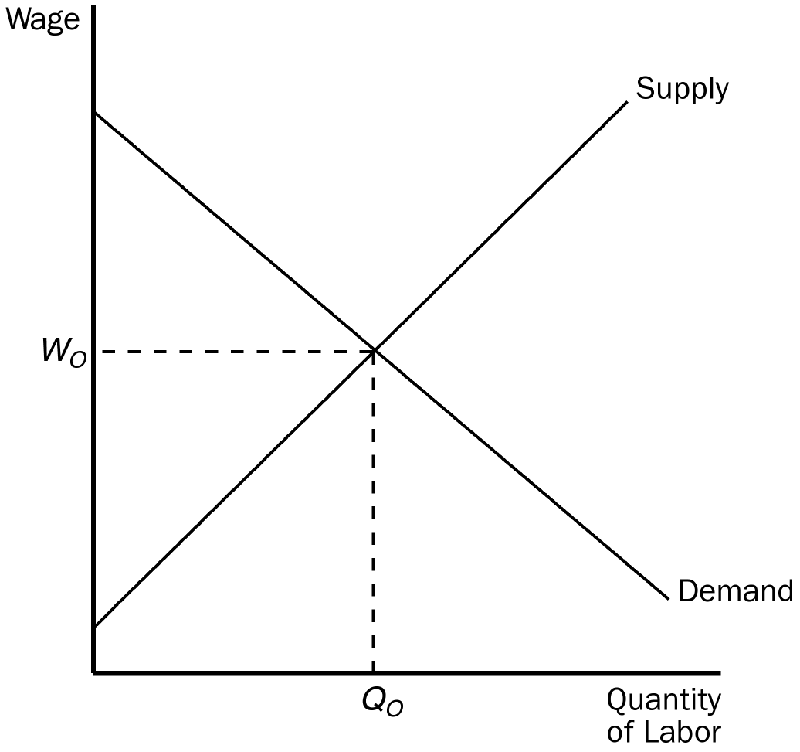

130. According to the graph, if the government imposes a minimum wage above Wo, it is likely to
a. increase employment to a level above Qo.
b. reduce employment to a level below Qo.
c. provide more income to the working poor than they collectively received before the minimum wage was set.
d. have no effect on employment.
ANSWER: b. reduce employment to a level below Qo.
TYPE: M SECTION: 3 DIFFICULTY: 1
131. Critics of minimum-wage legislation would suggest that an effective minimum wage would be set at a level
a. above Wo, and employment would rise above Qo.
b. above Wo, and employment would fall below Qo.
c. below Wo, and employment would rise above Qo.
d. below Wo, and employment would fall below Qo.
ANSWER: b. above Wo, and employment would fall below Qo.
TYPE: M SECTION: 3 DIFFICULTY: 1
132. Which political philosophy would be more closely associated with evaluating the process by which economic outcomes arise rather than the economic outcomes themselves?
a. Utilitarianism
b. Liberalism
c. Libertarianism
d. None of the above are correct.
ANSWER: c. Libertarianism
TYPE: M SECTION: 2 DIFFICULTY: 1
133. Binding minimum-wage laws
a. are most effective at alleviating poverty when labor demand is highly elastic.
b. force a market imbalance between the supply and demand for labor.
c. increase the efficiency of labor markets.
d. are typically associated with a rise in employment among the poor.
ANSWER: b. force a market imbalance between the supply and demand for labor.
TYPE: M SECTION: 3 DIFFICULTY: 1
134. A high binding minimum wage,
a. impacts no one.
b. lowers the productivity of workers.
c. raises the cost of labor to firms.
d. All of the above are correct.
ANSWER: c. raises the cost of labor to firms.
TYPE: M SECTION: 3 DIFFICULTY: 2
135. Critics of the minimum wage argue that
a. labor demand is inelastic so firms can adjust production.
b. firms will still be able to adjust employment.
c. many minimum-wage earners are teenagers from middle-class families.
d. All of the above are correct.
ANSWER: c. many minimum-wage earners are teenagers from middle-class families.
TYPE: M SECTION: 3 DIFFICULTY: 2
136. Economists who support minimum-wage legislation are likely to believe that the
a. demand for unskilled labor is relatively inelastic.
b. demand for unskilled labor is relatively elastic.
c. supply of unskilled labor is relatively elastic.
d. supply of unskilled labor is relatively inelastic.
ANSWER: a. demand for unskilled labor is relatively inelastic.
TYPE: M SECTION: 3 DIFFICULTY: 3
137. For most government programs that are designed to help the poor,
a. the poor may not receive assistance because the poverty line varies so much that it makes them difficult to identify.
b. recipients of government assistance are often declared ineligible to receive assistance from private sources.
c. being poor is typically sufficient to qualify for assistance.
d. being poor, by itself, is typically not sufficient to qualify for assistance.
ANSWER: d. being poor, by itself, is typically not sufficient to qualify for assistance.
TYPE: M SECTION: 3 DIFFICULTY: 2
138. In the Temporary Assistance for Needy Families program, most families
a. must have both parents in the home to qualify.
b. are female head-of-household families in which the father is absent.
c. have adult children with disabilities living at home.
d. are ineligible to receive assistance from other support programs.
ANSWER: b. are female head-of-household families in which the father is absent.
TYPE: M SECTION: 3 DIFFICULTY: 2
139. A common criticism of government programs that are designed to assist the poor is that
a. those who receive assistance rarely meet the criterion for eligibility.
b. the majority of those below the poverty line refuse to accept government assistance.
c. they create incentives for people to become "needy".
d. they typically account for a majority of annual government expenditures.
ANSWER: c. they create incentives for people to become "needy".
TYPE: M SECTION: 3 DIFFICULTY: 1
140. The Temporary Assistance for Needy Families program has been criticized by some who claim the program
a. increases the number of poor.
b. encourages families to break up.
c. encourages illegitimate births.
d. All of the above are correct.
ANSWER: d. All of the above are correct.
TYPE: M SECTION: 3 DIFFICULTY: 1
141. Evidence suggests that
a. the longer a family is on welfare, the harder it is to get off welfare.
b. the best way to deter immigrants is to make legal aliens ineligible for many welfare benefits.
c. welfare dependency is embraced by over 80 percent of new welfare recipients.
d. legislation designed to limit the time a family can be on welfare will never be passed.
ANSWER: a. the longer a family is on welfare, the harder it is to get off welfare.
TYPE: M SECTION: 3 DIFFICULTY: 1
142. Opponents of legislation which proposes to limit the time a family can receive welfare benefits are most likely to argue that time limits are undesirable because
a. the money saved will be diverted to defense spending.
b. children will become innocent victims if parents are forced off welfare.
c. there is no evidence to suggest a pattern of welfare dependency.
d. long periods on welfare erode work skills.
ANSWER: b. children will become innocent victims if parents are forced off welfare.
TYPE: M SECTION: 3 DIFFICULTY: 1
143. Proponents of welfare reform claim that programs for the poor that do not establish a time limit on recipient benefits harm children by
a. forcing mothers to work outside the home.
b. encouraging a psychological dependency on government programs.
c. encouraging child abuse by absent fathers.
d. All of the above are correct.
ANSWER: b. encouraging a psychological dependency on government programs.
TYPE: M SECTION: 3 DIFFICULTY: 1
144. A negative income tax system would
a. make taxes more regressive.
b. sever the link between tax policy and income distribution.
c. collect from high-income households and give transfers to low-income households.
d. eliminate tax progressivity.
ANSWER: c. collect from high-income households and give transfers to low-income households.
TYPE: M SECTION: 3 DIFFICULTY: 2
145. The only qualification to receive government assistance under a negative income tax is
a. pre-school children.
b. to be enrolled in job training.
c. a working head-of-household.
d. a low income.
ANSWER: d. a low income.
TYPE: M SECTION: 3 DIFFICULTY: 1
146. Which of the following formulas is most representative of a negative income tax proposal?
A. Taxes Owed = (1/4 of Income) × $2
b. Taxes Owed = (1/2 of Income) × 3/4
c. Taxes Owed = (1/2 of Income) + $15,000
d. Taxes Owed = (1/3 of Income) – $15,000
ANSWER: d. Taxes Owed = (1/3 of Income) – $15,000
TYPE: M SECTION: 3 DIFFICULTY: 2
147. Assume that the government proposes a negative income tax that calculates taxes owed by the formula, Taxes Owed = (1/3 × Income) – 10,000. If a family doesn't earn any income, how does the negative income tax affect them?
a. They will receive an income subsidy of $1,000.
b. They will receive an income subsidy of $3,000.
c. They will receive an income subsidy of $10,000.
d. They will not be affected at all, since the negative income tax requires a family to earn income.
ANSWER: c. They will receive an income subsidy of $10,000.
TYPE: M SECTION: 3 DIFFICULTY: 3
148. Assume that the government proposes a negative income tax that calculates taxes owed by the formula, Taxes Owed = (1/3 × Income) – 10,000. A family that earns an income of $60,000 will
a. pay $10,000 in taxes.
b. receive a subsidy of $3,000.
c. receive an income subsidy of $10,000.
d. neither pay taxes nor receive an income subsidy.
ANSWER: a. pay $10,000 in taxes.
TYPE: M SECTION: 3 DIFFICULTY: 1
149. Assume that the government proposes a negative income tax that calculates taxes owed by the formula, Taxes Owed = (1/3 × Income) – 10,000. A family that earns an income of $30,000 will
a. neither pay taxes nor receive an income subsidy.
b. receive an income subsidy of $500.
c. pay a tax of $1000.
d. pay $600 in taxes.
ANSWER: a. neither pay taxes nor receive an income subsidy.
TYPE: M SECTION: 3 DIFFICULTY: 1
150. An actual tax provision in the United States that works much like a negative income tax is the
a. Earned Income Tax Credit.
b. state sales tax deduction.
c. deduction for charitable contributions.
d. mortgage interest rate deduction.
ANSWER: a. Earned Income Tax Credit.
TYPE: M SECTION: 3 DIFFICULTY: 1
151. Supporters of the Earned Income Tax Credit point out that it does all of the following EXCEPT
a. does not discourage recipients from working.
b. is less distortionary than other anti-poverty programs.
c. distributes income more fairly than other anti-poverty programs.
d. applies only to the working poor.
ANSWER: c. distributes income more fairly than other anti-poverty programs.
TYPE: M SECTION: 3 DIFFICULTY: 1
152. Critics of a place-based poverty program believe that such programs
a. cause benefits to go disproportionately to property owners in the targeted areas.
b. offer no way to monitor the success of the program.
c. create incentives to keep the poor in the ghetto.
d. Both a and c are correct.
ANSWER: d. Both a and c are correct.
TYPE: M SECTION: 3 DIFFICULTY: 2
153. As a general rule, anti-poverty programs as a group
a. encourage saving among recipient groups.
b. impose a very low marginal tax rate on income.
c. are only made available to those with no other source of income.
d. impose disincentives to work.
ANSWER: d. impose disincentives to work.
TYPE: M SECTION: 3 DIFFICULTY: 1
154. Plato concluded that in an ideal society the income of the richest person would be no more than _______ times the income of the poorest person.
a. 8
b. 6
c. 4
d. 2
ANSWER: c. 4
TYPE: M SECTION: 0 DIFFICULTY: 2
155. Common criticisms of welfare programs include all of the following EXCEPT the programs
a. create incentives for people to become needy.
b. encourage families to break-up.
c. encourage illegitimate births.
d. create a drug dependency.
ANSWER: d. create a drug dependency.
TYPE: M SECTION: 3 DIFFICULTY: 1
156. Trends do not support the view that the decline of the two-parent family is largely a symptom of the welfare system because welfare benefits have
a. risen but the percentage of children with one parent has declined.
b. fallen but the percentage of children with one parent has declined.
c. risen but the percentage of children with one parent has risen.
d. fallen but the percentage of children with one parent has risen.
ANSWER: d. fallen but the percentage of children with one parent has risen.
TYPE: M SECTION: 3 DIFFICULTY: 1
157. According to Edward Glaeser, place-based welfare programs
a. create entitlements such as the GI Bill.
b. create entitlements such as the Earned Income Tax Credit.
c. create enterprise zones.
d. All of the above are correct.
ANSWER: c. create enterprise zones.
TYPE: M SECTION: 3 DIFFICULTY: 1
158. In-kind transfers are politically popular because
a. they provide food and shelter.
b. they provide cash with the vouchers.
c. allow resale of food stamps for cash, if needed.
d. the public believes that the aid is not going to support addictions.
ANSWER: d. the public believes that the aid is not going to support addictions.
TYPE: M SECTION: 3 DIFFICULTY: 2
159. An example of a tax provision that works much like a negative income tax is
a. Medicaid.
b. food stamps.
c. Earned Income Tax Credit.
d. housing projects.
ANSWER: c. Earned Income Tax Credit.
TYPE: M SECTION: 3 DIFFICULTY: 1
160. A “culture of poverty” is used to explain
a. ghettos and slums.
b. welfare, Medicaid and food stamps.
c. effective marginal tax rates that may exceed 100 percent.
d. the Workfare program because of time limits imposed.
ANSWER: a. ghettos and slums.
TYPE: M SECTION: 3 DIFFICULTY: 1
161. The minimum wage is likely to
a. create more unemployment in the long run than in the short run.
b. create more unemployment in the short run than in the long run.
c. create the same amount of unemployment in the long run as in the short run.
d. not have any effect on unemployment.
ANSWER: a. create more unemployment in the long run than in the short run.
TYPE: M SECTION: 3 DIFFICULTY: 3
162. Suppose a family’s tax liability were calculated using the formula, Tax Liability = .4(income) – $12,000. What is the marginal tax rate?
a. –.4
b. .4
c. .6
d. –.6
ANSWER: b. .4
TYPE: M SECTION: 3 DIFFICULTY: 2
TRUE/FALSE
1. The invisible hand of the marketplace acts to allocate resources efficiently, but it does not necessarily ensure that resources are allocated fairly.
ANSWER: T TYPE: T SECTION: 0 DIFFICULTY: 1
2. When the government enacts policies to make the distribution of income more equitable, it distorts incentives, alters behavior, and makes the allocation of resources less efficient.
ANSWER: T TYPE: T SECTION: 0 DIFFICULTY: 1
3. The bottom fifth annual family income of the U.S. 2000 distribution of income was under $19,250.
ANSWER: F TYPE: T SECTION: 1 DIFFICULTY: 1
4. The rise in women’s labor-force participation has been the same across all income groups.
ANSWER: F TYPE: T SECTION: 1 DIFFICULTY: 1
5. The top 5 percent of U.S. annual family income in 2000 was $160,250 or more.
ANSWER: T TYPE: T SECTION: 1 DIFFICULTY: 1
6. A U.S. family earning $80,000 would be in the top 20 percent of income distribution.
ANSWER: F TYPE: T SECTION: 1 DIFFICULTY: 1
7. Some of the fluctuations in the measured poverty rate reflect the form of government assistance rather than the true extent of economic deprivation.
ANSWER: T TYPE: T SECTION: 1 DIFFICULTY: 1
8. About half of black and Hispanic children in female-headed households live in poverty.
ANSWER: T TYPE: T SECTION: 1 DIFFICULTY: 1
9. A person’s lifetime income smoothes out the highs and lows of the life cycle. Therefore lifetime incomes are surely more equally distributed across the population than are annual incomes.
ANSWER: T TYPE: T SECTION: 1 DIFFICULTY: 1
10. The data used to measure inequality is based on annual income but people really care about their standard of living, so these measurement tools give an incomplete picture.
ANSWER: T TYPE: T SECTION: 1 DIFFICULTY: 2
11. Because permanent income includes transitory changes in income, permanent income is more equally distributed than is current income.
ANSWER: F TYPE: T SECTION: 1 DIFFICULTY: 2
12. There is a very strong correlation between the income of a grandfather and the income of a grandson.
ANSWER: F TYPE: T SECTION: 1 DIFFICULTY: 1
13. Fewer than 3 percent of families are poor for eight or more years.
ANSWER: T TYPE: T SECTION: 1 DIFFICULTY: 1
14. A family’s ability to buy goods and services depends largely on its transitory income, which is its normal, or average, income.
ANSWER: F TYPE: T SECTION: 1 DIFFICULTY: 1
15. About four out of five of the 2.7 million households with net worth over $1 million made their money on their own.
ANSWER: T TYPE: T SECTION: 1 DIFFICULTY: 2
16. The proper goal of the government, Utilitarians claim, is to maximize the sum of utility of everyone in society.
ANSWER: T TYPE: T SECTION: 2 DIFFICULTY: 1
17. The utilitarian case for redistributing income is based on the assumption of diminishing marginal utility.
ANSWER: T TYPE: T SECTION: 2 DIFFICULTY: 1
18. The maximin criterion would lead to a completely egalitarian society.
ANSWER: F TYPE: T SECTION: 2 DIFFICULTY: 1
19. According to libertarians, the government should take from some individuals and give to others in order to achieve a more equal distribution of income.
ANSWER: F TYPE: T SECTION: 2 DIFFICULTY: 1
20. Libertarians believe that the government should enforce individual rights to ensure that everyone has the same opportunity to use his or her talents to achieve success.
ANSWER: T TYPE: T SECTION: 2 DIFFICULTY: 1
SHORT ANSWER
1. Explain the relationship between labor earnings and the distribution of income.
ANSWER: A person’s earnings depend on the supply and demand for that person’s labor, which in turn depends on natural ability, human capital, compensating differentials, discrimination, and so on. Because labor earnings make up about three-fourths of the total income in the U.S. economy, the factors that determine wages are also largely responsible for determining how the economy’s total income is distributed among the various members of society. In other words, they determine who is rich and who is poor.
TYPE: S SECTION: 0 DIFFICULTY: 1
2. Explain how economic mobility affects measures of inequality and poverty (use facts to support your explanation).
ANSWER: Section 1d, p. 434
a. temporary – 1/4 of all families fall below the poverty line in a typical 10 year period
b. fewer than 3 percent of the families are still poor after 8 years
c. almost no correlation between the income of the grandfather and grandson.
TYPE: S SECTION: 1 DIFFICULTY: 1
3. Explain U.S. income inequality in 2000, when measured using percent of total before-tax income.
ANSWER: Section 1a, p. 429
In 2000 the bottom fifth of all families received 4.3 percent of all income, and the top fifth of all families received 47.4 per-cent of all income. In other words, even though the top and bottom fifths include the same number of families, the top fifth has about ten times as much income as the bottom fifth.
TYPE: S SECTION: 1 DIFFICULTY: 1
4. While the US distribution of income appeared to remain stable over time, closer inspection revealed distinct trends since 1935. What are these trends?
ANSWER: Section 1a, p. 429
At first glance, the distribution of income appears to have been remarkably stable over time. Throughout the past several decades, the bottom fifth of families has received about 4 to 5 percent of income, while the top fifth has received about 40 to 50 percent of income. Closer inspection of the table reveals some trends in the degree of inequality. From 1935 to 1970, the distribution gradually became more equal. The share of the bottom fifth rose from 4.1 to 5.5 percent, and the share of the top fifth fell from 51.7 percent to 40.9 percent. In more recent years, this trend has reversed itself. From 1970 to 2000, the share of the bottom fifth fell from 5.5 percent to 4.3 percent, and the share of the top fifth rose from 40.9 to 47.4 percent.
TYPE: S SECTION: 1 DIFFICULTY: 1
5. Present the basic premise of the life-cycle theory and discuss why it is used to dispel concerns about an unequal income distribution.
ANSWER: The life-cycle theory claims that spending in any one year is dependent upon lifetime income rather than income in any particular year. The normal pattern of life causes income inequality since young people and old people will have low "income" but their spending patterns may actually be less extreme. Therefore, this theory would assert that inequality in the income distribution overstates inequality in the distribution of well-being of individuals.
TYPE: S SECTION: 1 DIFFICULTY: 1
6. What is meant by a perfectly equal distribution of income? Use a graph to depict such a situation.
ANSWER:

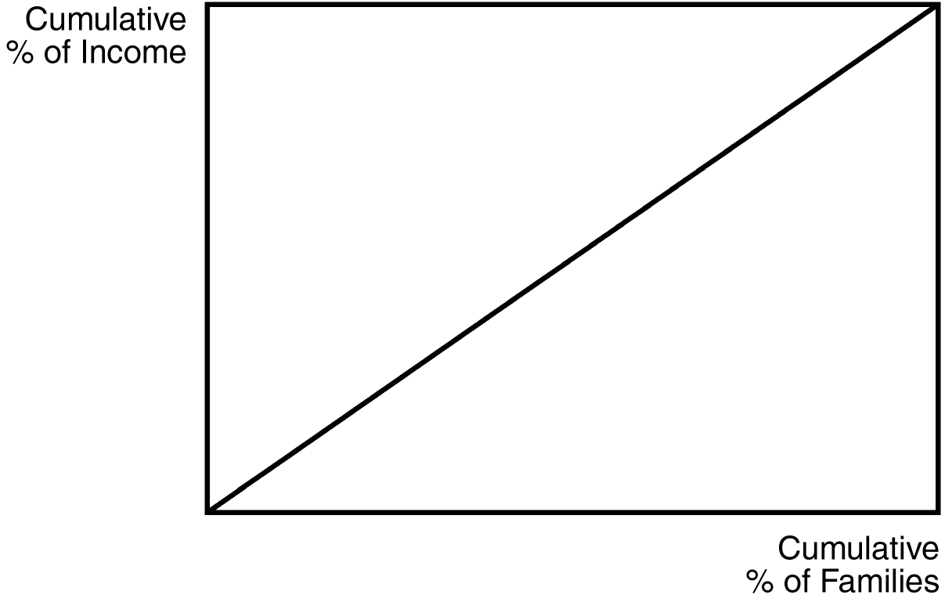

If income were equally distributed across all families, each one-fifth of families would receive one-fifth of income. Another way to put it is that 25 percent of all families would receive 25 percent of all income, 50 percent of all families would receive 50 percent of all income, etc.
TYPE: S SECTION: 1 DIFFICULTY: 1
7. Given the table shown, which country has a more equally distributed income? Explain your answer.

Country | Bottom Fifth | Second Fifth | Middle Fifth | Fourth Fifth | Top Fifth
Country A | 9.0% | 13.5% | 17.5% | 22.9% | 37.1%
Country B | 4.8% | 10.5% | 16.0% | 23.5% | 45.2%

ANSWER: Country A has a more equal income distribution. If income were equally distributed across all families, each one-fifth of families would receive one-fifth of income. Country A is closer to that situation than Country B.
TYPE: S SECTION: 1 DIFFICULTY: 1
8. Many people have been critical of statistics that are used to characterize income inequality on the grounds that as long as the average income of the poor is increasing, their position relative to the rich should not matter. Evaluate this critique.
ANSWER: Advocates of relative measures argue that we need to have some way to measure how the economic system allocates resources between rich and poor. Without relative measures it is difficult to evaluate the "fairness" of economic systems. On the other hand, obsessing about the relative distribution of income implies that we would be better off if everyone were equally poor.
TYPE: S SECTION: 1 DIFFICULTY: 1
9. Compare and contrast the "life cycle" hypothesis and the "permanent income" hypothesis. Is there a basis on which one can judge between these two theories or are they complementary? What are their respective implications for inequality in the income distribution?
ANSWER: Life-cycle variation in income is predictable by the "stage" of one's life. The permanent income hypothesis tries to account for random and transitory forces that affect income. In this sense these two theories are probably complementary. Both would indicate that standard measures of income distribution overstate inequality in the distribution of well-being.
TYPE: S SECTION: 1 DIFFICULTY: 1
10. A very small percentage of families lie below the poverty line for more than 8 years. Discuss how changing demographics and income mobility affect the standard measure of income inequality. Should standard measures be changed to account for these dynamics in the economy? Explain.
ANSWER: Changing demographics and mobility would tend to dampen the inequality of families across generations. Ideally, measures of the distribution in inequality should account for the transitory nature of income not only over lifetimes (permanent income) but also possibly over generations.
TYPE: S SECTION: 1 DIFFICULTY: 1
11. Explain what information is contained in the poverty rate statistic. Are there problems in using an absolute scale to measure poverty? If so, carefully explain what these problems are.
ANSWER: The poverty rate is the percentage of population whose family income falls below an absolute level called the poverty line. The poverty line is set by the federal government at roughly three times the cost of providing an adequate diet. Problems would include differing cost of living across broad geographic regions, not counting in-kind transfers, and no way to measure a true "standard of living".
TYPE: S SECTION: 1 DIFFICULTY: 1
12. Explain what is meant by "in-kind transfer" programs. Briefly outline the pros and cons associated with an in-kind transfer program.
ANSWER: These programs transfer goods and services to individuals who meet some criteria of need based on income. Advocates of in-kind transfers argue that such transfers ensure that the poor get what they need most and that society is not helping to support possible addictions. Advocates of cash payments argue that in-kind transfers are inefficient and disrespectful and that the government does not know what goods and services the poor need most.
TYPE: S SECTION: 1 DIFFICULTY: 1
13. Explain the concept of diminishing marginal utility and describe the role that it plays in the utilitarian argument for redistribution of income.
ANSWER: In this context, diminishing marginal utility refers to the principal that as a person’s income rises, the extra well-being derived from an additional dollar of income falls. The utilitarian argument of redistribution from rich to poor hinges on the fact that a dollar of additional income to the poor is valued more than a dollar of income to the rich. If this is not true, then the transfer from rich to poor would actually reduce the well-being of society.
TYPE: S SECTION: 1 DIFFICULTY: 1
14. List and then briefly outline the three prominent schools of thought in political philosophy. Identify one of the most well-known philosophers in each school.
ANSWER: according to utilitarianism the government should choose policies to maximize the total utility of everyone in society by attempting to achieve a more equal distribution of income. Jeremy Bentham and John Stuart Mill were the founders.
According to John Rawls and liberalism, the government should choose policies deemed to be just, as evaluated by an impartial observer behind a “veil of ignorance.” Rawl’s rule, the maximin criterion, emphasizes that the government should aim to maximize the well-being of the worst-off person in society.
According to libertarianism, the government should punish crimes and enforce voluntary agreements but not redistribute income. Libertarians argue that society itself earns no income—only individual members of society earn income. Robert Nozick was a libertarian.
TYPE: S SECTION: 1 DIFFICULTY: 1
15. Explain how a “leaky bucket” can be used to illustrate the utilitarian argument that complete equalization of income should not be attempted.
ANSWER: Utilitarians reject complete equalization of income because they believe that people respond to incentives. As such, redistribution reduces a person’s work effort and can actually lead to less total income generated in the economy. If the government attempts to redistribute income from the rich to the poor with taxes, because distorted incentives and deadweight loss are associated with these taxes, a portion is lost, as if the government were transporting the redistributed income in a leaky bucket.
TYPE: S SECTION: 1 DIFFICULTY: 1
16. Assume that the government proposes a negative income tax that calculates taxes owed by the formula, Taxes Owed = (a × Income) – b. A family with an income of $40,000 pays $5,000 in taxes, and a family with an income of $12,000 receives an income subsidy of $2,000.
a. What is the tax liability of a family with an income of $50,000?
b. At what level of income will a family neither pay taxes, nor receive an income subsidy?
ANSWER: a. $7,500; b. $20,000
TYPE: S SECTION: 1 DIFFICULTY: 3
17. Assume that the government proposes a negative income tax that calculates taxes owed by the following formula,
Taxes Owed = (1/3 × Income) – $10,000.
Compute the tax that would be owed given each level of income.
a. $120,000
b. 90,000
c. 60,000
d. 30,000
e. 0
ANSWER: a. $30,000; b. 20,000; c. 10,000; d. zero; e. –10,000
TYPE: S SECTION: 1 DIFFICULTY: 1
18. The table below reflects the levels of total utility received from income for each of four members of a society.
Total utility derived from various income levels

Income Peter Paul Mary Jane
$1 15 32 20 16
$2 29 61 38 30
$3 42 87 54 42
$4 54 110 68 52
$5 65 130 80 60
$6 75 147 90 66
$7 84 161 98 70
$8 92 172 103 72

a. Assume that the society has the following income distribution:
Peter $3
Paul $7
Mary $5
Jane $3
Is it possible for the government to increase total aggregate utility by redistributing income among members of society? Explain your answer.
b. Assume that the government has $19 to allocate among the four members of society. (Assume that no one has any income to start with.) If the government is interested in distributing income in a way that maximizes aggregate total utility, how should it distribute the $19 of income?
c. Does the table above describe a situation characterized by diminishing marginal utility? Explain your answer.
ANSWER: a. No. If a dollar is taken from anyone, the possible net gain in utility to any other person is less than or equal to the loss incurred by the person it is taken from.
b. Peter $4
Paul $7
Mary $5
Jane $3
c. Yes. Marginal utility declines as income increases for each person.
TYPE: S SECTION: 1 DIFFICULTY: 1
19. Assume you are a critic of welfare reforms that impose a time limit on the number of years a person is eligible for welfare benefits. What is the foundation of your critique?
ANSWER: The critique is based on the premise that most people on welfare would not make a "choice" to pursue a life on welfare if it were not thrust upon them. As such, we have an obligation to help them as long as there is demonstrated need.
TYPE: S SECTION: 1 DIFFICULTY: 1
20. In an article written by Edward Glaeser, programs that are person-based are said to be superior to place-based programs. What reasons does he give for this thinking?
ANSWER: Glaeser makes two points to support his argument. The problem with place-based programs is that they create incentives to keep the poor in the ghetto. These policies make it more attractive for the poor to stay in high-poverty areas. Also, place-based programs suffer from the fact that their benefits go disproportionately to property owners in the targeting areas and not to the intended beneficiaries.
TYPE: S SECTION: 1 DIFFICULTY: 1
21. Outline the possible work disincentives created by anti-poverty programs. Is there a way to solve this problem, without causing other forms of inefficiency to arise? Explain your answer.
ANSWER: A high marginal tax rate exists on welfare transfers. There is inherently a trade-off between burdening the poor with a high effective marginal tax rate and burdening taxpayers with costly programs to reduce poverty.
TYPE: S SECTION: 1 DIFFICULTY: 1
22. Using demand-supply analysis, show why some economists argue that an effective minimum wage will result in higher unemployment among those groups of workers affected by the minimum wage.
ANSWER:

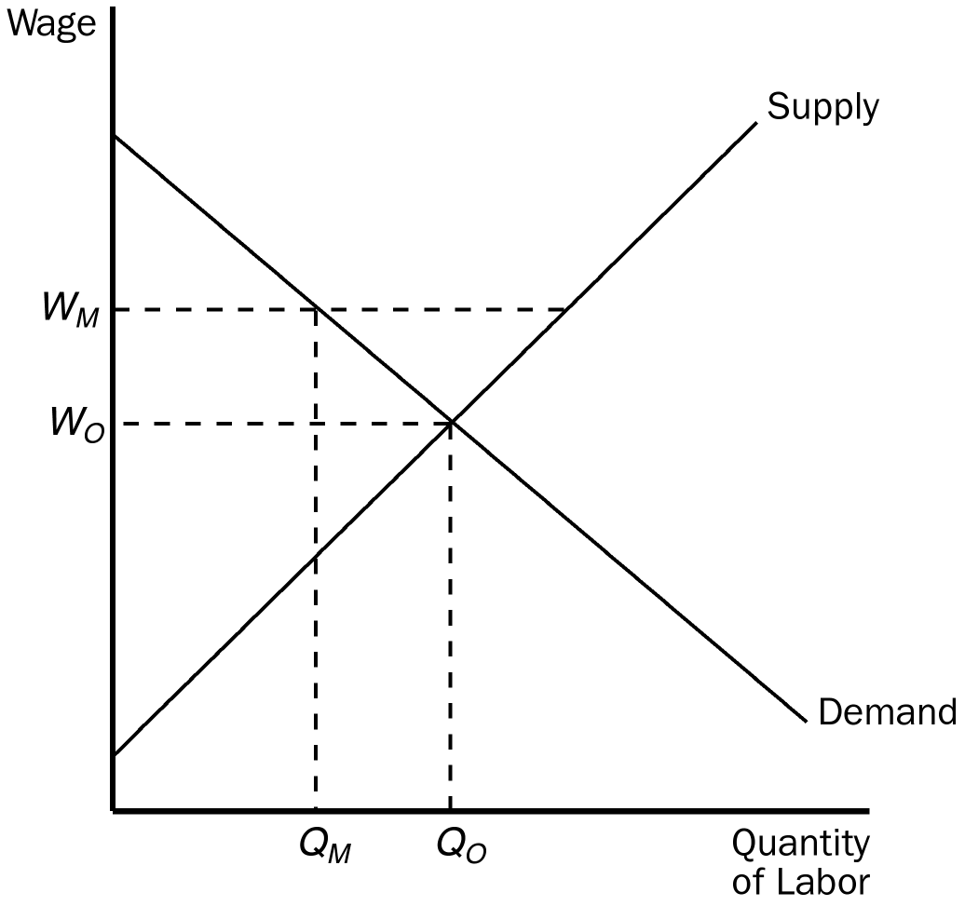

Before imposing a minimum wage, the quantity of labor demanded would be Qo. After a minimum wage is imposed about Wo at Wm, the quantity of labor demanded would be at Qm, which is less than Qo. Fewer workers would be demanded and those workers from Qm to Qo would be unemployed.
TYPE: S SECTION: 1 DIFFICULTY: 1
23. Using demand-supply analysis, show how the elasticity of demand of labor determines the magnitude of unemployment when an effective minimum wage is imposed.
ANSWER:
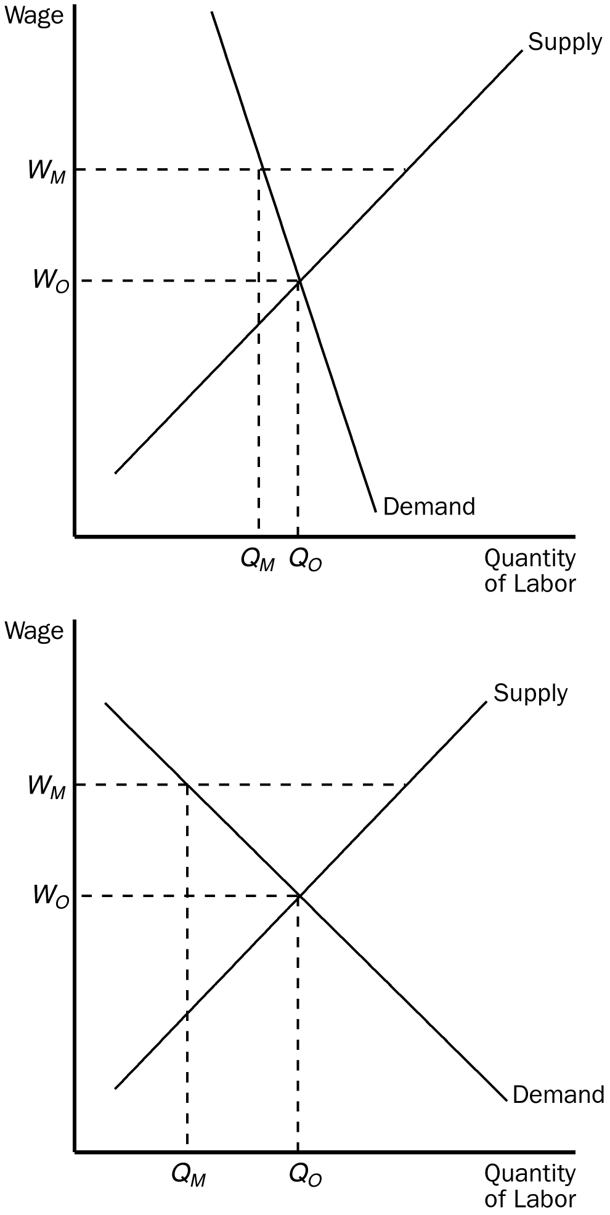
Graph A shows a more inelastic demand for labor and Graph B shows a more elastic demand for labor. Notice that the distance from Qm to Qo (which represents the decrease in quantity demanded of labor and therefore the unemployment that would result) is greater in Graph B than Graph A. This illustrates that when an effective minimum wage is imposed, the more inelastic the demand for labor, the less the resulting unemployment.
TYPE: S SECTION: 1 DIFFICULTY: 1

